1

1

1

1

**OUR TEAM**

**MISSION AND VISION**

VISION AND MISSION

OUR TEAM

ABOUT US

To create a world where young people are encouraged to celebrate fun and excitement of science and technology, and inspire them to take science and technology based career paths to become tomorrow’s much needed technology leaders.

Encourage, develop and implement exciting, mentor based programs that inculcate interest towards science and technology in the minds of young people, inspiring them to meet the challenges of the global, technology-driven society through innovation, collaboration, and creative problem solving.

**HOW WE WORK**

**CONTENT**

**RE-SEARCH**

**DISCOVER**

**IF you want to know more about the service of NEBOT and the content we provide to our partner and franchise.**

**NEBOT is an organization, actively involved in Re-search work for the wee-fair of the society and also to provide better learning platform for student with new ideas.**

**IF you are the founder of any Respected school in Nepal and wants to discover the structure of the NEBOT.**

3a 3b 3c 3d

2b

2a

1

MANAGMENT

**ORGANIZATION STRUCTURE**

**DISCOVER**

1= management

**IT department**

* Project manager
* Senior Developer
* Junior developer
* Architect
* Product manager

2a=Robotic Team

2b=Helping team

3a=research and development

3b=student enrollment team

3c=IT department

3d=marketing team

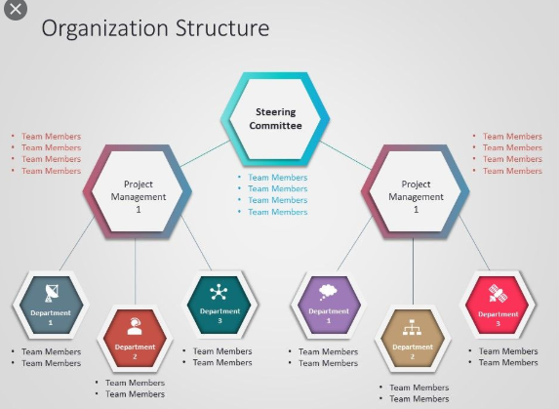

Marketing team

* Digital marketing expert
* Content creator
* Content writer
* Data strategist.

**STUDENT ENROLMENT TEAM**

* Syllabus design for student
* Structure the way of presenting the syllabus
* Daily review with the student and teachers.
* Aware the student with new technology.
* Enroll student with national and international competition.

4

3

2

1

READ MORE

READ MORE

READ MORE

READ MORE

**RESEARCH**

**Robotics research market was at $500 million in 2010 and is anticipated to reach $60 billion by 2020. Contributing to this advancement, ASIMOV Robotics is committed to provide reliable and sophisticated hardware and software modules to leverage robotics for research.**

**RESEARCH ROBOTICS**

1. INDUSTRIAL ROBOTIC ARM---A robotic arm, sometimes referred to as an industrial robot, is often described as a 'mechanical' arm. It is a device that operates in a similar way to a human arm, with a number of joints that either move along an axis or can rotate in certain directions. The robotic arm is used for multiple industrial applications, from welding, material handling, and thermal spraying, to painting and drilling. The robotic technology also provides human-like dexterity in a variety of environments.
2. DOG BOT---These days many growers are looking for solutions to reduce labor in the fields and pack houses, robotics is one of the ways to do this, but replacing pickers of delicate fruit such as strawberries with a robotic picker is very challenging, the technology is not yet available and would not be affordable for many growers.
3. SERVICE ROBOT---A service robot is a robot which operates semi- or fully autonomously to perform services useful to the well-being of humans and equipment, they exclude manufacturing operations, and they are capable of making decisions and acting autonomously in real and unpredictable environments to accomplish determined tasks.
4. IOT SOLUTION---The internet of things, or IoT, is a system of interrelated computing devices, mechanical and digital machines, objects, animals or people that are provided with unique identifiers (UIDs) and the ability to transfer data over a network without requiring human-to-human or human-to-computer interaction.

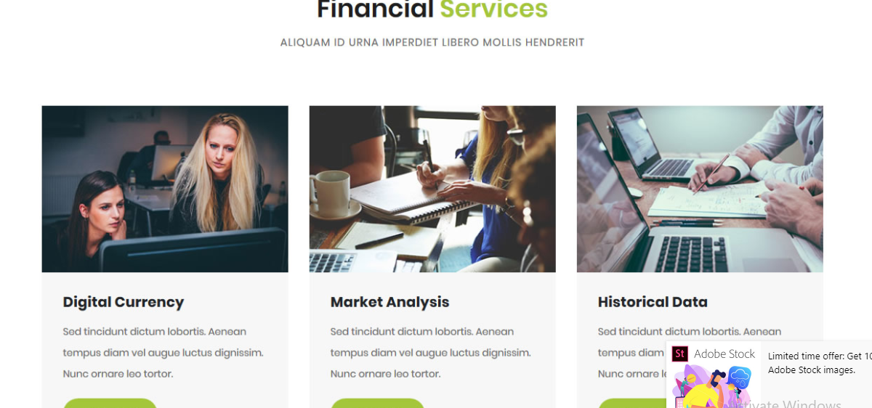

FINANCIAL=NEBOT

DIGITAL CURRENCY=IT SOLUTIONS

MARKET ANALYSIS=HELP

HISTORICAL DATA=SOCIAL AWARENESS

**IT Solutions**-- NEBOT Pvt Ltd provides IT solutions to the schools of Nepal connected to the company for free, this IT solution will help to improve the school business environment, our IT solution will provide the power to is organization to take the direct control over the attendance of the student as well as teachers. School can easily access the review of the student and the parents for the improvement of the schools , school can share their notice via IT solution.

**HELP**--NEBOT will help faculty of the school teaching any other subject if the faculty member demands any help from the team member of NEBOT for the better understanding of the related subject, NEBOT will be happy to help them 24*7.

**SOCIAL AWARENESS**---NEBOT is an responsible organization of the society. NEBOT feel it’s on responsibility towards society so, our company conduct social awareness program for the welfare of the society. If any other organization or an individual wants to conduct the social awareness program our company will always ready to help you for free.

**CONTACT US**



**NEBOT is a not-FOR—Profit organization incorporate under the companies Act of Nepal**

**OUR ADDRESS CONTACT EMAIL CONTACT PHONE**

**PRIVACY POLICY**

This privacy policy sets out how NEBOT Works uses and protects any information that you give us when you use this networking platform on the website www.NEBOT.in

This Privacy Policy is intended to explain what data we collect from Users of the website. A “User” means either a member of the NEBOT Community” or a non-Member who is simply visiting the Website.

NEBOT may change this policy from time to time by updating this page. You should check this page from time to time to ensure that you are happy with any changes.

LOG FILES

We will be collecting none personally identifiable information like many other Web sites, NEBOT makes use of log files. The information inside the log files includes internet protocol ( IP ) addresses, type of browser, Internet Service Provider ( ISP ), date/time stamp, referring/exit pages, and number of clicks to analyze trends, administer the site, track users movement around the site, and gather demographic information. IP addresses and other such information are not linked to any information that is personally identifiable.

COLLECTION OF YOUR INFORMATION

We may collect the following information:

* Name
* Contact information including email address
* Demographic information such as gender, postcode, preferences and interests
* Profile Photo
* Username or Login Ids on other platforms such as Facebook and Google

We require this information to understand your needs and provide you with a better service, and in particular for the following reasons:

**Internal record keeping.**

We may use the information to improve our products and services.

We may periodically send promotional emails about new products, special offers or other information which we think you may find interesting using the email address which you have provided.

From time to time, we may also use your information to contact you for market research purposes. We may contact you by email, phone, fax or mail. We may use the information to customize the website according to your interests.

We are committed to ensuring that your information is secure. In order to prevent unauthorized access or disclosure we have put in place suitable physical, electronic and managerial procedures to safeguard and secure the information we collect online.

**GET TO KNOW ABOUT OUR COMPANY**

**NEBOT** Robotics is an organization having highly motivated and energetic team, taken the responsibility to lift the society in the field of robotics science and technology for the betterment of human kind.

NEBOT Robotics is an education company, which is also into robotics automation manufacturing and research.

School and collages student in the age group 11yrs to 23yrs are trained thoroughly by our expert engineers in robotics technology. STEM(science , technology , engineering and mathematics) concept are imbibed in our student to help them understand the school academy and again meaningful knowledge.

Our training programs are carefully and scientifically designed to bring out the innovation and creativity through out-of-the-box approach while giving the child an opportunity to explore Science and Technology. These programs help students to understand science and mathematics concepts in a fun learning manner. Once the student understand the applications of the academic concepts, learning interest increases which further results in higher marks or grades in school academics.